A Narrative Summary of Robert Karasek’s New Economy Conference Keynote:

“From the Demand/Control Model to
A Feasible Economy of Innovative and Healthy Work”
I. From Active Work to Conducive Economy
II. The Feasibility of a New Innovative Work and Economy Model
III. What about Work and Stress? - Integrating A New Level of D/C Theory
IV. Implications. Pulling it together: Innovation, Stability and Stress Moderation

Introductory Summary
The original Demand/Control (D/C) model’s hypotheses mapped organizational goals and organizational structure into context parameters for both positive and negative components of worker wellbeing: developmental, Active Work, and risk-prone work: high Job Strain.
In this presentation the D/C model’s Active Work and Job Strain concepts are expanded and generalized - with rather dramatically broadened new theory – to allow of description of and review of feasibility of a New Economy of Innovation and Health.

I. From Active Work to Conducive Economy:
A. Current Challenges: Work, Stress, and Economy
There is a huge, but poorly-defined social problem growing rapidly: the deterioration of psychosocial wellbeing in our free-market global economy, in which bad work organization/bad management are on the pathway to unhealthy and deadly working conditions. The examples now span all occupations, and counties, and all institutional sectors <Link to Full Text*>, but are often almost invisible in public dialogues.
Management’s response to this tsunami of societal health risk is very often that it is the competition with other companies (and now, all countries) that forces their own cost cutting and compromised worker protection. In many ways this is considered to be the only “feasible” management solution - since it is based on a conventional “economic logic” which seems to hold unchallengeable power in current private and public debates.
However there are simultaneously immediate additional needs for a totally rebuilt “economic dialogue” - now- to create employment, for sustainability, and to reverse increasing inequality <Link Full Text-Econ. Crit./VI>.
Theories of psychosocial work organization could be central to these dialogues.

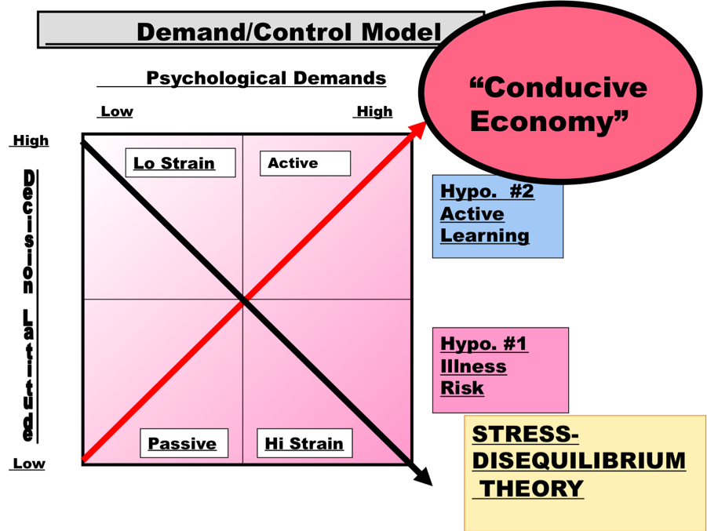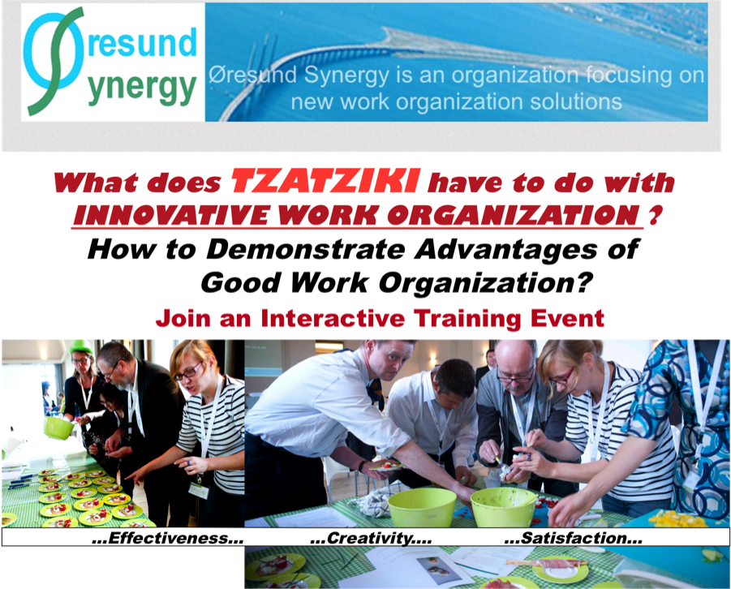

B: The New Economy: Developmental and Innovation-focused (Conducive)
Work organization-based economic innovation, related to Active Work, has become subject of much recent European discussion about economic development (“EUWIN,” see citations in 2014, Dhondt, et al, see Dortmund-Brussels.., 2012, Pot, et al, 2015).
We present demonstration of this “new” work conception in a video of a work organization simulation game called “Tzatziki” - based on the D/C model and now being used by us and others in Europe (developers: Flanders Synergy). This is our first demonstration of feasibility. The accompanying game video (https://youtu.be/5Bue-QkdUJY Peter H-Rasmussen) shows that Active Work organization ideas (video’s Green Group) - participative and with broad skill usage possibilities, are far more productive, yield more consistent quality, and are quite dramatically more creative, when compared to the “classic model” of production. The “classic model’s” principles are based on limited skill-use and task control, combined with high task demands. Such work organization (video’s Orange Group) produces far LESS output, and that output is often of POOR and distasteful quality. But: these classic principles underpin our global, mass-production economy now, and since 1776 in their cornerstone, Chapter 1 role in Adam Smith’s Wealth of Nations (the “bible” of free-market economy)! And: we have actually already accumulated decades of Socio-Tech work redesign experience consistent with Active Work. The Tzatiki game utilizes a simple, task-based work organization and a “mass-produced” product. But below we go further: beyond mass-production: to customer adapted production.
The alternative is Conducive Economy: a form of economy based on skill development and an extension of D/C model’s Active Work ideas. Conducive Economy links development of customer’s wellbeing and capability development to jobs requiring intelligence and creative flexibility (Karasek, 1999, “ Alternative Economy,” 2004b).
The primary characteristic of this new production is the focus on skills and capabilities (Slide below). The Conducive Production process is based on a dynamic linkage between the development of capabilities in BOTH the worker AND in the customer. The output of Conducive Productive is a “tool-like” contribution to the customer’s growth of capabilities (a “good” new computer program, or even a “good” new child care aid – or a “good” truck (Slide #_)). This output is a new type of “skill-based Value (Conducive Value)” which is “non-material” and is linked directly to the person or organization in the form of “living” capabilities. This capability-related output distinguishes it from the logical basis of conventional economic theory, anchored in “dead” material outputs/inputs.
In this model skills bring with them a “need” to be used. These needs are the drivers that support a healthy new social dynamic linking creative actors in a new, Conducive Economy - keeping the economy “alive.” They are of course supplementary to biological needs, but could underpin a new stage of economic development.

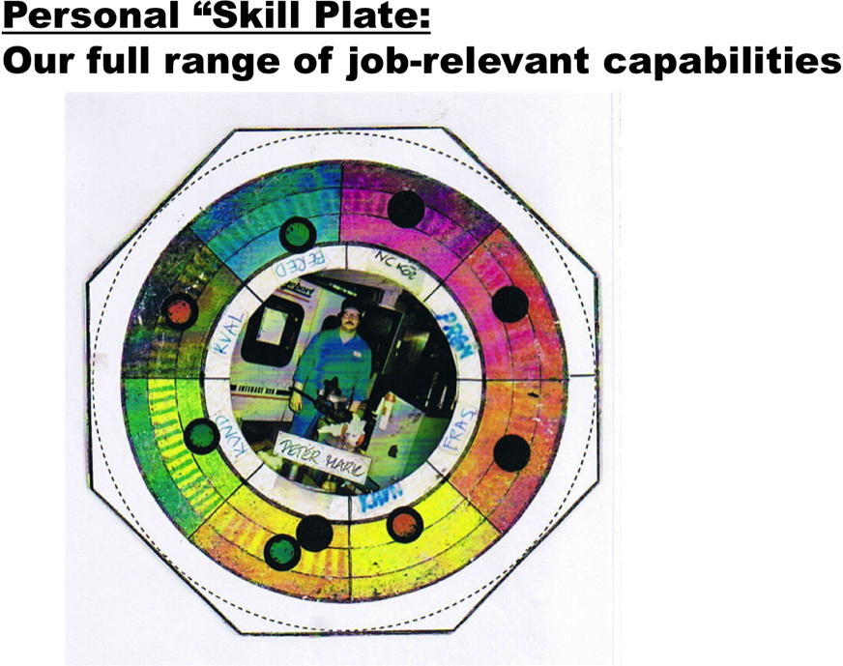 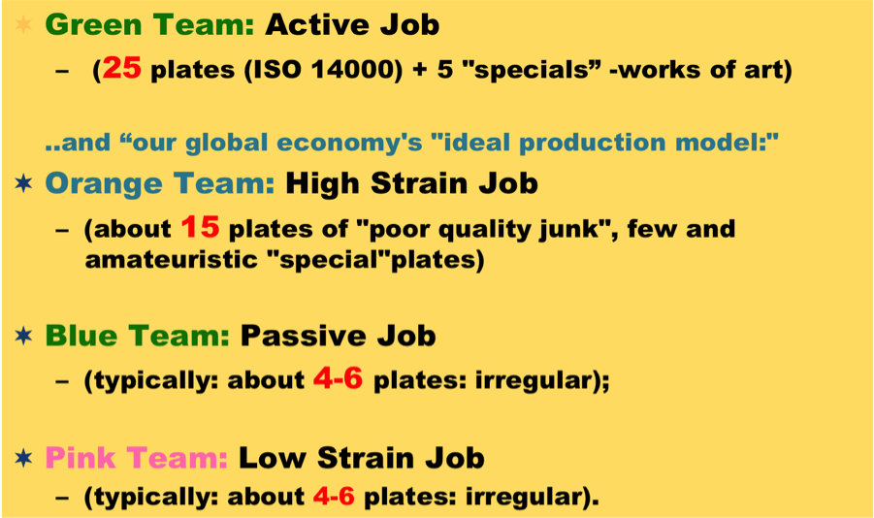

This growth of capabilities in the customer promotes renewed demand for a new cycle of “skill-inducing” production – securing adaptive and creative work for the original workers. Altogether this new form of Producer/Consumer linkage is the core of a new economic dynamic (Slide #__). The process both requires - and produces - “educated customers.”
Conducive production is based on the broad range of skills now possessed by many working individuals (Slide above – skill plate) in, for example, the mature developed economies of EU, US, or segments rapidly growing in the moderately developed (BRIC-like) economies. This is a vast difference from the presumptions, used first by Adam Smith from over 200 years ago based on unskilled farm workers, to validate maximally specialized labor: ideas then further developed by Frederick Taylor and Henry Ford to design “classic” mass production.
Thus: our current advanced economy “social capital” of skilled work forces – and now especially educated, underemployed youth - can be much more effectively used in Conducive Production: further arguing for “feasiblility.”

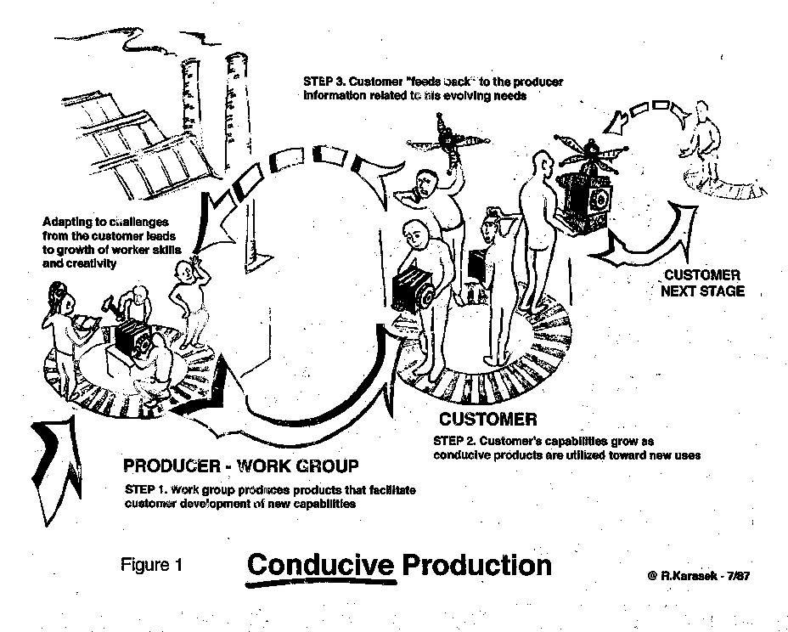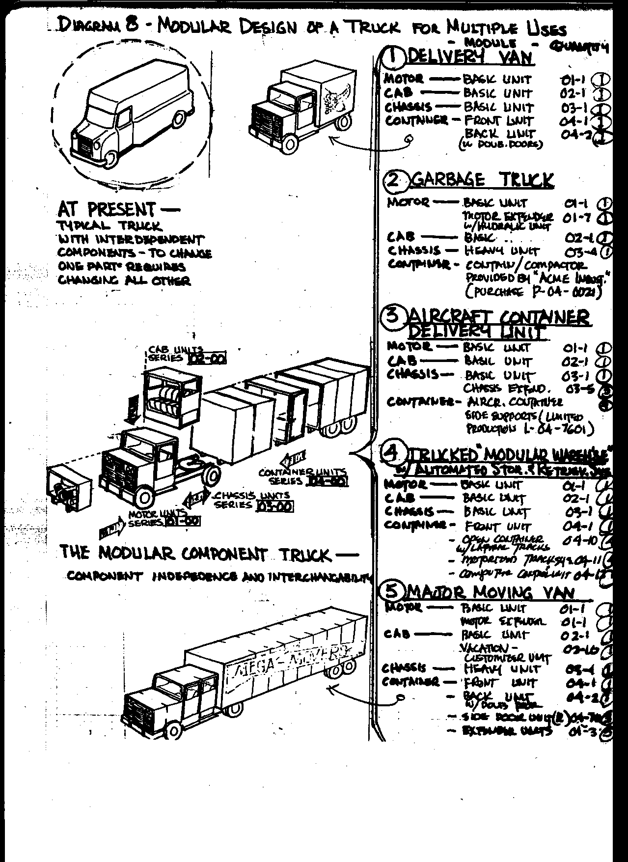

II. The Feasibility of a New Innovative Work and Economy Model:
We now discuss how Conducive Economy can be integrated with our existing Commodity-based, mass-production market Economy at the economy-level in a complementary manner - while simultaneously offering an alternative policy pathway. The Slide below shows these two economies - one above and one below - and each with a “producer” and a “consumer” side. The top of the figure is simply the very standard picture of the free-market “Commodity” Economy from a typical Chapter 1 of any introductory economics textbook. At the person level (i.e. Consumer (right side)), the conventional market’s Commodity Economy contributes the basic material necessities of food and shelter for consumers, while the Conducive Economy produces psychosocial wellbeing and social integration – otherwise missing. At the industry level (i.e. Producer (left side)), the conventional Commodity Economy provides the physical infrastructures of roads, power grids, factory and school buildings, while the Conducive Economy contributes new ideas and innovation, and provides new skills and training – which we all know are now critical to our current and future society (but otherwise are omitted in the textbook free-market model). This integration is of course important at the societal level – but we would claim that analogous synergistic linkages also can occur for the organization in its market and community context.
Thus: these two pathways above can easily be complementary – they need not be mutually exclusive. This is the third, major argument for feasibility – now at both the organizational level and at the social policy level: providing a new, general economic solution (However, some important questions arise here - as noted in the Section IV).

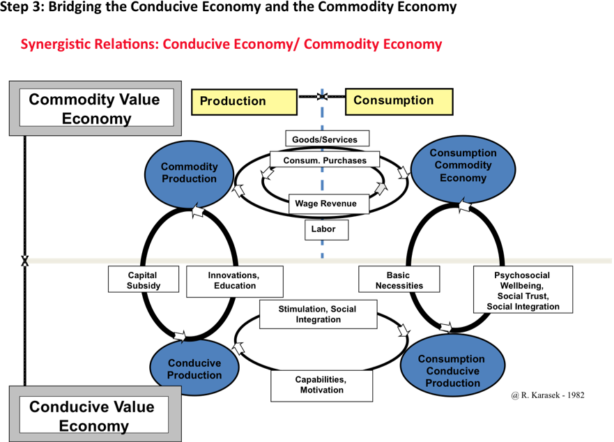

In many developed countries there are already many “company-based” innovation-focused management solutions available, focusing on teamwork, and skill-building work re-organizations. With careful modifications to fit the Conducive Production conception (i.e. a refocusing of goals toward in favor of capabilities of living persons/organizations instead of just material output – and adding inclusive multi-party dialogues) these could represent a partial experience-base for enhanced worker wellbeing in work organizations as well. They further demonstrate feasibility: the knowledge exists from a business and organizational perspective (and the decades of consistent Socio-Tech experience, (see for example discussion: Dhondt, et al, 2013, Pot, et al, 2015, Dhondt, Pot, and Krann, 2014),
Another area of development also indicates future possibilities: the traditional role of middleman-based customer/producer communication is already changing markedly in many industries and countries. This is occurring via social media/internet in many industries that are the sources of the most dynamic growth. In these cases, a significant part of this information now often goes directly from customer to large producer organizations via digital media. So: might we ask: hasn’t a part of the new Conducive Communications “revolution” linking the Producer and the Customer already happened? Of course, the “creativity-link” implied by Conducive Production is not occurring in many of these cases (for example Apple iPhone’s horrible jobs in China - see discussion <link>), and certainly not for the “commodity producers” the Walmarts, Exxons, etc.
So: what was happened -? The full model of “conducive communication” is needed to insure Active Jobs have their developmental potential, larger scale viability, and this is not yet in place. New types of communication, all the way through to the direct shop-floor and mid-level producers, and “relational coordination” (Karasek, 2004b, Gittel, 2010) will be needed. Nevertheless, these new digital communication developments are another “indication of feasibility (#5)” for such a New Economic model - if properly further developed.
A sixth, extremely important argument for feasibility is that The Conducive Economy is environmentally “Clean.” It does not use physical resources intensively, since it is labor-based. It could involve, for example, re-usable, modular, and service-like products – such as a “conducive truck” that supports growth of skills in truck use through “evolutionary upgrades” of the truck body, rather than its disposal and replacement (Slide #16). <Link to Full Text: Clean/Conducive File>. Such an evolving truck is both conducive and environmentally clean - consistent with ideas mentioned in environmentalists’ ”Cradle-to-Cradle,” and circular economy design contributions. Some such form of new economic development will have to be a major part of ALL political change dialogues, for ANY sustainable future.
Altogether, the above results, these tools, and this new logic allow us to reject the claim, above, that managers have only one form of useful, “economics-like” logic to decide policy for modern workers and organizations. Fundamentally different, feasible alternatives do exist for them. At the societal level, broad new social dialogues could be developed.

III. What about Work and Stress? - An Integrating New Level of D/C Theory
A. Health - and Innovation: a new level of theory is needed for an integrated result
What about health and wellbeing – which are critical for a new economy, especially the ever-increasing risks of stress-related disease? We must make clear: by themselves: neither creative nor efficient production, nor Active Jobs, nor Job Control, nor even Conducive Economy - without further specification of health effects – could represent fully “feasible” solutions for a New Economy.
How could “health” - and moderated “stress” levels - be maintained in such a creatively engaging and dynamic economy? How shall, for example, young IT professionals avoid “overstress,” or, how shall we all avoid it as we become “innovative” in the 24/7 Internet global economy?
First, we note that there is a very extensive - and basically hypothesis-confirming and already well-cited - research literature on the D/C model’s Job Strain hypothesis and disease (Slide #20), but this will not be further reviewed in this presentation (Reader Note: this Keynote was presented to an audience already well-informed in this area).
However, we will note that the Swedish data on Job Strain and chronic disease disability shows clearly that extensive job stress costs are borne, not only by individuals, but by society as a whole (Canivet, et al, 2010) (Slide #22). Across many modern societies, the magnitude of the costs could be enormous. They could affect up to 2/3 of major disability/ chronic health care costs to the society - since categories of mental strain/depression, muscular skeletal disorders, and cardiovascular disease are all clearly affected. These cost usually do not appear on company balance sheets - they are often externalized to “the public” (like environmental costs). And usually they are still invisible in “public economy/politics” dialogues. We must bring these costs into the discussion.
A second fact, remarkable in the context of medical research, is that Job Strain seems to have its explanatory effects over a very wide range of disease outcomes. How could we find only a single process, physiological or psychological, that could represent “The” disease development pathway from Job Strain, with so many outcomes? Indeed it seems that the explanation must be, instead, be found at a very general level.
Further, the broad nature of many new social and economic burdens in our global economy requires the full use of the underlying generality of the new Demand/Control concepts. It certainly requires a multi-level understanding since modern work involves: (a) the job, (b) the organization, (c) the supra-organization - often; (d) the market; and (e) the global economy.
So: the new, extended theory is grounded in a VERY generalized set of formulations used in systems theory: the limitations on processes that transform generally available Energy into the very specifically Ordered Energy we need to do as Work (the so called “Second Law”) (Slide #24). This approach is first used to describe the self-regulatory stability processes that are the basis for Health in our complex, global economy. These principles (Karasek, 2008) can then be further applied to understand the processes of Growth in complex systems. Actually, the principles provide a broad enough framework for understanding both how systems can re-organize themselves and grow into higher levels of complexity (the Active Work hypothesis - now as Conducive Production), and how systems can dissolve into “diseased” versions, with lower levels of complexity (the Job Strain hypothesis - now as the Stress Disequilbirum Theory, below).
We can also approach the theory from an organizational perspective. The “open-systems” organization model, originally “borrowed” from the physical sciences, proved have a robust history in company organization analysis (Katz and Kahn, 1966 and 1978) well describing the functioning of complex bureaucracies and their environmental dependencies, however their shortcomings are now too great: they could not address stress problems at work and their described structure could not avoid waste human potential for creativity and innovation.
So a revised approach to the “open systems” model is needed to understand the complex resources and control that exist linkages between the multiple levels of modern work environments – all of which must now be addressed to find suitably comprehensive solutions to both stress-prevention areas, and the company development areas.
Thus, this new D/C theory “edition”, based on multi-level energy and order processes, provides a linkage between Innovation and Health in the New Economy - when integrated with the Conducive Production concepts above. For example, we will see how both health and growth are both based on platforms of stability and energy flows, and coordination of sub-systems (Slide #21). We can understand more specifically how the high-level hypotheses (a) Stress inhibits learning, and (b) Learning inhibits Stress could operate (Karasek and Theorell, 1990, p 99).
The Health/Stress explanations are provided by the D/C model’s companion extension for Job Strain: the Stress-Disequilibrium Theory (SDT) (Karasek, 2008). The new core explanation of the stress-disease linkage is based on the self-regulatory stability of a complex system (Karasek, 2008). It requires a new core concept of demands: the requirement of coordination—of ordering and precision - is the determining “load” for the central control system - loads that are obviously very relevant for the complexity of our global economy.
The new theory’s multi-level generality allows modeling of the idea of “ordering capacity” needed to understand stress and chronic disease (for example: multi-level physiological system function failure), and is also needed to effectively explain the opposite processes of growth in complex systems (for example: also the multi-level task, organization and external market aspects of product development, or safety climate policies).

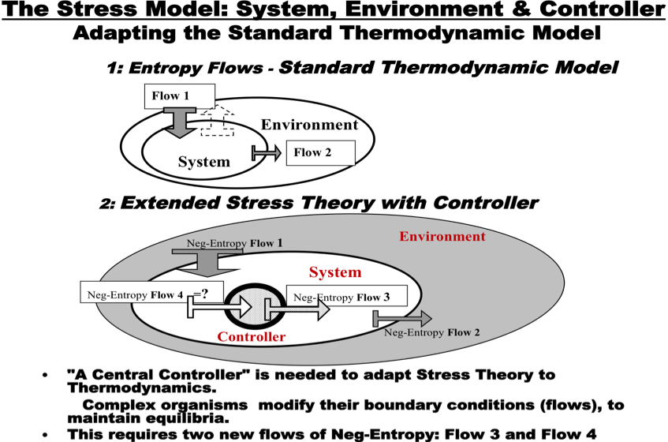

B. Correspondence to the Demand/Control conceptions
There is a new Demands explanation in SDT: available energy in the outside environment (“cheap,” disordered) must continually be transformed into the “ordered energy” (Work) needed to sustain the organisms very complex organization. When this happens “smoothly” it results in an “equilibrium of flows.” This is done in cycles of building up “ordering capacity” (at Rest) – and then using up this capacity to meet the challenges of daily life. (Slide#_).
To get this job done, the organism must exert “Control” over its environment. First, control over the organism’s sub-systems – using its internal coordination “skills” to steer the organism - and in a second stage, using its Skills and Degrees of Freedom (autonomy) externally in the environment (i.e., its Decision Latitude) to grab cheap available energy at one level in the environment and converts it to building blocks for action programs at a higher level (creating “ordering capacity”). This allows the organism to both maintain its ongoing, day-to-day stability - and – to sometimes generate a “surplus” and integrate a new source of external “resources” - for growth.
The broad idea of “control capacity” has a long history in job design literature (de Sitter, 19__). However, this SDT-based approach represents a new, multi-level theory of high-level “control capacity” creation, not otherwise in the organization literature (but see below, Implications/Dollard & Karasek).
The Demand/Control model’s new theory extensions go very significantly beyond physical science’s standard “system/environment” paradigm. A “three-level” model has been needed, see Slide above, nesting one systems/environment pair inside another. All three levels are needed to understand the concept of “stress.” In the case of human physiology or psychology these three levels could be understood as the (a) central nervous system (the controller), the (b) physiological sub-systems (which might get “sick;” for example, the cardiovascular, system, the endocrine system, etc), and then, finally the (c) environment.
Or, switching focus dramatically: for the organization this new three-level structure allows worker/management relations to be modeled: (a) the central management (as controller), (b) the employees in many departments, and (c) then the societal environment.
What is the status of evidence for this new system-level version? We do have evidence: workplace field study heart/health empirical confirmation testing workplace exhaustion and loss of regulatory capacity (Collins et al, 2005) (Slide #29), and discussion of multi-level physiological levels of order capacity creation show several lower levels which are incontrovertibly consistent (Karasek, 2008, Table1). But the theory’s predictions are so broadly general, that the above explanations are primarily still speculative at many levels of prediction.
However, precisely because of this same generality of the SDT hypotheses, we can also present some “suggestive” evidence from an organization-level phenomena based of the same mechanisms: explanations that can rather easily be broadly accepted as valid. For example, it would seem to be a very reasonable conclusion, in light of recent years’ business news, that organizations could “fail” only because of decisions failure at the management level (i.e., high-level mistakes) - even when the overall (low-level) functions of company operation are otherwise completely “healthy.” Also, on the “positive-side” at the organization-level: “solutions” could only mainly be effective when prioritizing high-level environment actions for companies (i.e., new capital, market changes, etc.), since, for example, workers may already be working a close to maximum capacity.
We must clearly acknowledge, that at both the physiological and organizational process levels, the next step in confirmation of such very generalized new D/C theory involves more specifically constructed testing. We need to do this research (Karasek, et al, 2010).
A simple summary of this implication of SDT can be found in the new broader definition of "control" (for the JCQ 2.0 (Job Content Questionnaire) which is just now being substantially updated to accommodate these new conceptions): “Decision Latitude is the freedom for people to act and develop using their repertoires of skills, within the social structures where they have made their social investments, and where they get their major life-sustaining rewards.” (Karasek, 2008, p.119).
Thus, these D/C model extensions provide a THEORETICALLY UNIFIED APPROACH, at multiple and integrated functional levels to allow understanding the challenges of both work stress and work-based innovation in an integrated manner - to find truly realistic solutions.

IV. Implications: Pulling it all together: Innovation, Stability and Stress Moderation
The implications of the extended new D/C theories could thus generate new work organization-related policy discussions in many areas.
In the area of labor market policy it offers solutions to resolve the young workforce problems of too few jobs, or too “studipifying” jobs. To address the need to maintain the ‘workability” of the aging workforce, it offers models of new flexible and adaptive work organization.
In the area of health, it presents an entirely new theory of disease causation, based SDT-defined process of high-level ordering capacity creation. This is the basis for the new claim that chronic disease can be - alone - the result of failure in persons high-level self-regulatory capacity - not the result of a deficiency in any low level biological function (bio-molecular or genetic based). A major implication of this theory is that for this set of common chronic disease conditions, the ONLY pathway to health is by high-level reduction in risk - i.e. social level “prevention” of health risks condition, for example, at work. Neither drug, nor surgical, nor genetic, nor even life-style interventions could be effective here. This would substantially increase the priority of social intervention-based health promotion.
Also, we discuss the implication of the New Economy’s multi-level systems model for establishing “psychosocially safe” organizational policies, and for understanding multilevel organizational-based innovative production (Slide #_).
For the full advantages of the Conducive dynamic to be realized new organizational developments in the Consumer/Producer linkage will be required (even beyond Rifkin’s “prosumers”): persons on the “production-side” will have to develop new “Languages of Use” - and simultaneously new groupings of consumers will have to develop new “Languages of (partial) Production.”
A new perspective on a “decentralized” economic/social policy processes, using new forms of “creative communication” (together with Gittell’s “relational coordination,” and ideas such as the “sharing economy”) to focus on individual-level and community level development, are reviewed. These could bring social and economic policy influence back “closer to home,” and avoid a global economic “race-to-the-bottom” in wages and working conditions.
Furthermore, we get a clearer understanding of the true costs of global economy. The global economy complexity – more and more immediately now affecting the daily lives of many – is a very significant current source of current health risks. Many of these are modulated at the job, company, industry, and country level (Slide #_). These now DIRECTLY increase demands for “ordering capacity” (see Slide below), whose burdens can add significantly to work task and work/family stressor loads.
Finally, we can understand why the innovation thus required for economic growth in advanced economies - innovative production - must have a basis in workplace and labor economic stability, not the socio-economic “deregulation” advocated by unrestricted free-market economic policy. We can understand why rigidly neo-liberal policies of “ removing the safety nets” to motivate workers are not likely to succeed.

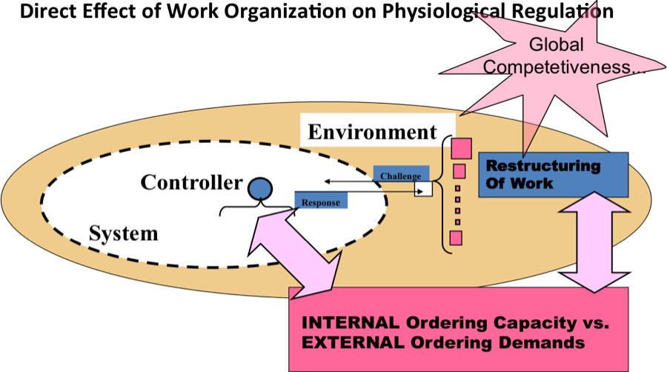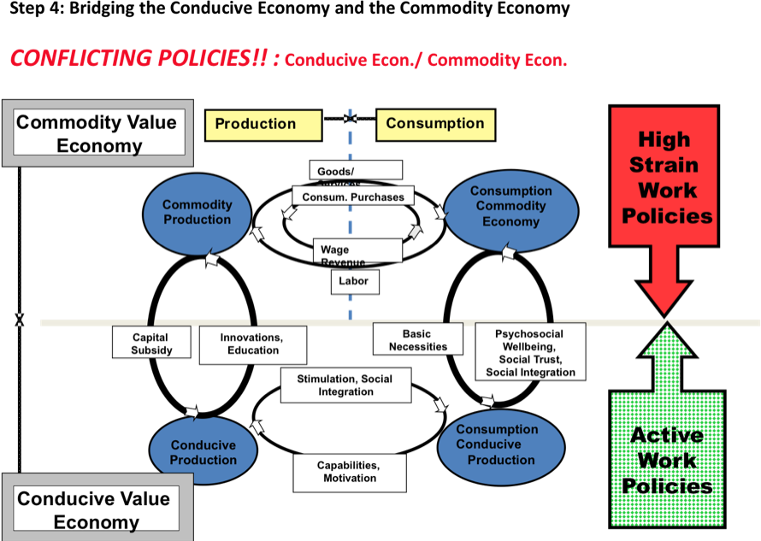

The added new theoretic extensions to the D/C model via SDT and Conducive Production explain under what conditions work can be both Innovative and Healthy – in a dynamic economy that is stable, with active jobs. It explains the “stability” constraints necessary to insure that Active Work’s skill development processes can be handled successfully by individuals - in a healthy way. It explains how a new economic context can make a more sustainable social platform than we seem to have today, with new social-economic communications pathways to enable meeting the challenges of innovation, creativity, and social cohesiveness.
And it explains the unfortunate reasons why very often today many new work organization solutions and “buzz words”, FAIL to yield either innovation - or health - for many persons and organizations in our current economic context.
Now we can understand why more work-based capability development and education are solutions to the complexity of a global economy - but ONLY IF work processes are re-designed to allow for intelligent jobs and intelligent customer linkages - and continue to provide a basic platform of physical and social security.

V. Mastering Critical Challenges in Economy, Health, and Work:
A. A New “Associationalist” D/C Platform
Altogether, the two extended theoretical frameworks: Conducive Economy (Active work extended) and Stress-Disequilibrium Theory (Job Strain extended) comprise the extended and generalized “Associationalist Demand/Control Model” (A. D./C. model) - consistent with the original DC model. These major extensions incorporate new, multi-level system theory that can span individual level, task-level, organization-level, and external socio-economic factors.
So what is really “new” here is that the A. D./C. model has a logical core that supports a far more general approach, with basic principles based on the association-of-parts and coordination processes – no longer exclusively on specific Material Properties of Things (or as material value evaluated in the conventional economic marketplace).

B. Feasibility of the New Economy of Innovation and Health
The utility of such a New Economy depends on its ability to solve new problems - for individuals and for society, as discussed in the Implication review above (IV). Here, it is meant to be a basis for future policy discussions.
Furthermore, in this talk we argue for “feasibility” – now - of this new model in terms of practical workability and “real world” availability of these solutions at the organizational level, i.e., for organizations, and for their managers and labor leaders. Seven arguments for the “organizational feasibility” of such a New Economic model are presented above: (1) innovation and effectiveness; (2) use of current labor-force skills; (3) synergistic links to current market economy; (4) availability of organization change methods; (5) possible fit to new digital communications; (6) environmentally clean; and (7) preservation of “workability” of aging workers.
Indeed, in this light it can be seen that it is the status-quo mass-production, global economy that seems infeasible: for creating employment, for sustainability, for health, and for social equity - particularly if extrapolated into the future <Link to Econ. Crit./VI>.
Thus, in the many ways above it could be said the New Economy we advocate is already here – as a clear “necessity.” But if it is already here, how could it also be “new?”
It is of course “new” in that it differs dramatically from the current reality in most jobs and in most countries.
In reality many of the current “political policies” (unrestricted free-market) often favor the Commodity Economy, and indirectly can restrict the existing and much needed Conducive sections of our current “mixed economy.” Thus, we can and do have “conflicting policies” (see Slide above __) - in spite of economic realities that could favor a joint approach. These conflicts should be avoided by comprehensive policy discussions that are built on a broad new platform.
While conducive economy maybe “feasible” in the future in some Western locations, this may hardly be obvious for the Chinese workers producing iPhones, Indian call-center workers, or even obvious for marginally employed people in the West. The advantages of the Conducive Economy approach occur mainly when each individual experiences a “mix” of both Commodity and Conducive value. How do we make sure the “creative” job content is equally distributed, and how a can we insure that “development” moves in the desired direction, and not the reverse?
Will the “old” Commodity economy break down as unstable and wasteful, with Conducive Economies outcompeting those with the less conductivity? Will the Western countries create a “false/partial” global Conducive Economy – with creative jobs in the most developed countries - based on a foundation of free-market Commodity Economy in China with poor quality (and low wage) jobs? Who: which groups and “new” political party platforms, will make progress in this area politically feasible? What are the new social movements that could contribute are realizing the Conducive Economy - locally?
While there are many difficult questions with such a new approach, given the “infeasibility of doing nothing” now, we hope that the directions proposed above do at least demonstrate the reality of many of the already available “partial solution steps,” and hopefully provide at least one alternative template for essential multi-focal - integrated - social and economic dialogues.
What is perhaps most new is the “narrative” that could link currently separated areas: the very general model of complex system growth and decline, translated into a very expanded and integrated discussion of the social bases of wellbeing and value across multiple spheres of life, multiple intellectual disciplines, multiple social actors, and segments of society.

C. Conclusion
The current Challenges for Health and the Production in New Work Organization involve physiological, psychological, sociological, and political-economic wisdoms. Of course, technological and financial issue will remain, but, the claim is made here that many of the modern economy’s challenges can be best now met by integrating more centrally into the dialogue a new generation of policy-minded psychologists and sociologists. Their new understandings must, of course be better linked to production and market wisdom than is now usually the case, but then they could potentially make important new contributions about the mechanisms of “social relational production” and social relational challenges to health
Our current conventional “economist’s toolbox” is lacking when it comes to job creation, social equity, health, and sustainability – it has not been bringing us tools powerful enough for the needed future vision. (Slide --).
Thus, a list of current “headline” economy policy issues, could probably be better addressed by the vey interdisciplinary audience in this room – albeit acting together with the current expert groups at the International Monetary Fund, the World Bank, or by our evermore free-market-focused governmental and policy institutions (Slide --) - than by those groups acting alone.
Of course, since almost all social policy dialogues now include some form of economic issues, economists will certainly remain central in ”tomorrow’s” social policy dialogues. But - we now suggest - not alone. These debates must now be joined without delay: By You.

NOTE: THIS IS A DRAFT DOCUMENT ( may not be cited w/o permission)
a. Links and Slide #’s (to be completed)
b. The Full Bibliography (to be completed)
Partial Bibliography Only

A. Correspondence to other theoretically-related social scientific approaches

Ancona D. and H. Bresman, X-teams: How to Build Teams That Lead, Innovate and Succeed Hardcover use pre formatted date that complies with legal requirement from media matrix, Harvard Business School Publishing, 200712.

Bohle, P., M.Quinlan, M. McNamara, C.Pitts & H. Willaby (2015): Health and well-being of older workers: comparing their associations with effort–reward imbalance and Pressure, Disorganisation and Regulatory Failure, Work & Stress DOI: 10.1080/02678373.2014.1003995

Bruhn P., and P. Hagedorn-Rasmussen, At arbejde med social kapital, - kortlægning af eksisterende erfaringer Rapport udarbejdet for BrancheArbejdsmiljøRådene Social & Sundhed, Undervisning & Forskning samt Finans / Offentlig Kontor & Administration , Danmark

Brynjolfsson, E., and A. McAfee. The Second Machine Age: Work Progress, and Prosperity in a Time of Brilliant Technologies. New York: W. W. Norton & Company, 2014.

Brynjolfsson, E., and A. McAfee. Race Against The Machine: How the Digital Revolution is Accelerating Innovation, Driving Productivity, and Irreversibly Transforming Employment and the Economy, 2011.
De Sitter, L.U., Hertog, J.F. den & Dankbaar, B. (1997). From complex organizations with simple jobs to simple organizations with complex jobs. Human Relations, 50 (5), 497–534.

Dhondt, S. et al, “Dortmund/Brussels Position Paper on Workplace Innovation, 26 June 2012, http://ec.europa.eu/enterprise/policies/innovation/files/dortmund-brussels-position-paper-workplace-innovation_en.pdf

Dhondt, S., F.Pot, K. Kraan , (2014),"The importance of organizational level decision latitude for well-being and organizational commitment", Team Performance Management, Vol. 20, Iss 7/8, pp.307 – 327

Gittel, J. H., ‘New Directions for Relational Coordination Theory,” Chapter 30,
(2011). "New Directions for Relational Coordination Theory," in Oxford Handbook of Positive Organizational Scholarship, pp. 74-94, eds. K.S. Cameron and G. Spreitzer. Oxford University Press.

Olesen, K.G., A.Thoft, P.Hasle, TS Kristensen; Virksomhedens sociale kapital – hvidbog; Det Nationale Forskningscenter for Arbejdsmiljø, Denmark, 2008

McGrath R., Columbia Univ. business school professor (2015) cites the need for “balance of change and stability is needed” in organizations. in( recent lecture in Copenhagen/ cited in Børsen, 12 August, 2015, p. 9)

Quinn, R. E., & Rohrbaugh, J. (1983). A spatial model of effectiveness criteria: Towards a
competing values approach to organizational analysis. Management Science, 29, 363–377.
doi:10.1287/mnsc.29.3.363

Rifkin, J. The Zero Marginal Cost Society: The Internet of Things, the Collaborative Commons, and the Eclipse of Capitalis, 2014, Palgrave McMillian,
Pot, F. & Dhondt, S. Workplace innovation. In: Mohr, B. & Van Amelsvoort, P. (Eds.). “Co-creating humane and innovative communities of work: The Evolution of STS Design Practice and Perspective”, September 2015 (forthcoming).
Katz D., & Kahn R. L. The social psychology of organizations.
New York: Wiley, 1966. 489 p.

Collins S, Karasek R, Costas K. Job strain and autonomic indices of cardiovascular risk. Am J Ind Med. 2005;48:182–93.

B. (Karasek: some main theoretical sources with an attached ReadMe file about those).
((1. Karasek and Theorell, 1990; especially Chap 3 pps. 86-103, and Chap 5; p. 187- p.197.))
2. R. Karasek, Low social control and physiological deregulation: The stress-disequilibrium Theory, towards a new demand-control model, Scandinavian Journal of Work, Environment & Health. 2008 ; vol. 6, nr. suppl., s. 117-135. - PDF
3. Karasek R, Collins S, Clays E, Bortkiewicz A, Ferrario M: Description of a large-scale study design to assess work-stress-disease associations for cardiovascular disease. Int J Occup Med Environ Health; 2010;23(3):293-312 PMID: 21306975
4. R. Karasek: P.-O.T.D. Research Project Guide, 2013 - Word doc
5. R. Karasek: New Work Organization and Conducive Value, (/Ed. T. Korver) Soc. Guids, 1999
6. R. Karasek, A Vacuum in Political and Economic Labor Policy? Bulletin of Science Technology and Society, (BSTS), 2004 24: 353-365. - PDF
7. R. Karasek, An Alternative Economic Vision for Healthy Work: Conducive Economy, BSTS 2004 24: 397-429. - PDF
8. R. Karasek, The Social Behaviors in Conducive Production and Exchange, BSTS 2004 24: 457-468. – PDF
9. R. Karasek, A Tool for Creating Healthier Workplaces: The Conducivity Process,
BSTS 2004 24: 471-479. - PDF.
10. M. Dollard and R. Karasek, “Building Psychosocial Safety Climate: Evaluation of a Socially Coordinated PAR Risk Management Stress Prevention Study,” in 2010 Houdmont, J. & Leka, S. (Eds.) (2010). Contemporary occupational health
psychology: Global perspectives on research and practice, Chichester,
UK: Wiley-Blackwell.

A major current limitation of the “standard” Economics 101 picture is that it presumed a basically closed, integrated national economy. But now the producers maybe in China, while the consumers may be in California: at vastly disparate wage and price levels.
A. For Health/Disease “...ordering capacity restoration occurs from the lower level, and thereby supports adaptive actions that are controlled from the level above (higher in energy). This basic relationship helps to define the nature of multi-level control processes. These relationships are very similar to Bernard’s “homeostasis” concept. To make this happen, inside the System there must be a “processing structure” which transforms disordered energy — with many degrees of freedom — into ordered work — at few degrees of freedom: i.e., accurate predictable Work. The Work output from one level (the lower level) provides the constraint structure to restrict the degrees of freedom on the cheap, disordered energy that is available at the higher level above: turning in into High-level Work (Flow 4 in Karasek — “the Neg-Entropy Pump”) [43]. Consequently, the processing structure is “built” using the critical outputs from the lower level systems as components. Thus, the low level contributes to the development of ordering capacity development at the higher level (i.e. to take a physiological example: the outputs might be enzymes, which at the next higher level are used to process simple input molecules and energy into the complex proteins needed for Work by the organism). (Karasek et al, 2010).
For Innovation/ Growth (see also footnote #2) The possibility of linking the producer and the consumer in a “Conducive,” skill-enhancing cycle would require new “Languages of Production - which could be understood by consumers (very simplified obviously), and new Languages of Use – which could be understood by Producers. In each case the language allow a “growth promoting” dialogue - based on the ability to “constrain” - to a manageable number - the enormous range of possible combinations of production/ consumption in a particular user group/ company context (These requirements are an additional stage based upon the self-regulatory requirements in footnote #2: Health /Disease).

